CHAPTER 8: Forces, energy and motion

Worksheet 8.7

Newton’s Third Law
Science Quest 10: pages 318–19
Answers
1. State Newton’s Third Law of Motion.
All forces occur in pairs; the forces are equal in magnitude but opposite in direction.

2. The following diagram shows a balloon rocket built by students to investigate motion. The balloon is mounted on a horizontal string using a length of drinking straw and masking tape.
 | 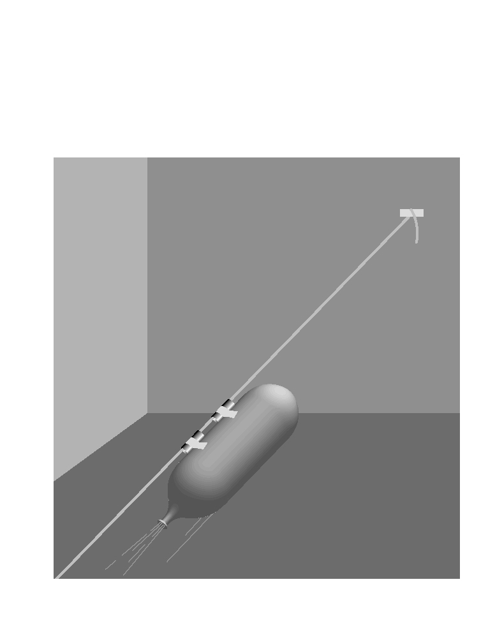 | The inflated balloon is then released.  (a) Where along the string will the balloon be moving at the greatest speed?  The greatest speed will occur when the balloon is initially released. This is when the force of the gas escaping is at its greatest and the reaction force acting on the balloon is at its greatest.  (b) Use Newton’s Third Law to explain why the balloon is propelled forward along the string.  The contracting rubber balloon pushes the air out of the open end of the balloon. The force of gases escaping from the balloon leads to a reaction force in which the gases push back on the balloon, which pushes it forward.
3. The photograph below shows a person pushing against a wall.
 |   Photo: Wavebreak Media Ltd / 123RF | The man is not moving even though he is pushing forward against the wall.  (a) What is the net force acting on the man?  Zero (he is not moving)  (b) If the man pushes with a force of 200 N on the wall, what is the force that the wall exerts back on him?  200 N (but in the opposite direction)  (c) The man is pushing back on the floor with his feet with a force 200 N. With what force does the floor push back on the man?  200 N (but in the opposite direction)
(d) Explain what would happen if he tried to do this on a very slippery floor.
As he pushes back against the slippery floor the lack of friction causes his foot to slide as the reaction force of the floor back on the shoe is too low. The low value of this force and the force of the wall pushing back on the man will cause him to fall down.

